**Phase 9 — Reports & Dashboards (Lead Tracking System)**

**A. Reports (Short Summary)**

* New Leads Report: Tracks newly captured leads this month.
* Converted Leads Report: Shows leads converted into opportunities/accounts.
* Leads by Source Report: Displays lead distribution by source (e.g., Web, Email, Phone).

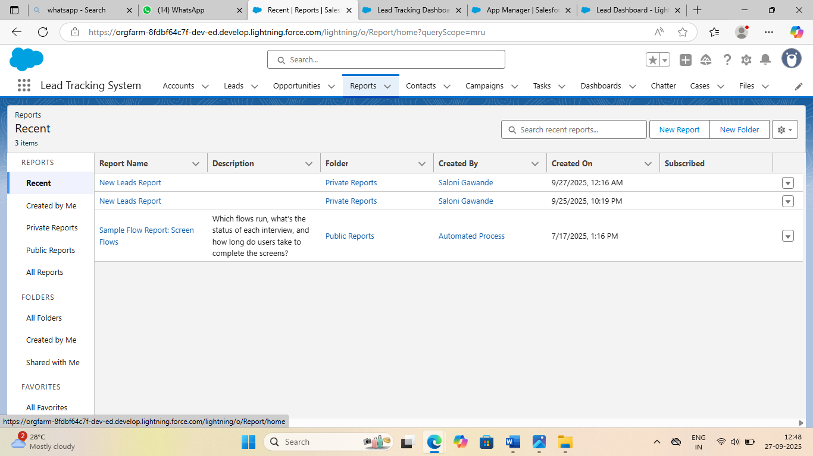

**B. Dashboards (Short Summary)**

* Lead Tracking Overview Dashboard: Combines multiple lead reports.
* Components include:
* - New Leads This Month (Bar Chart)
* - Conversion Rate Funnel (Funnel Chart)
* - Leads by Source (Pie Chart)

